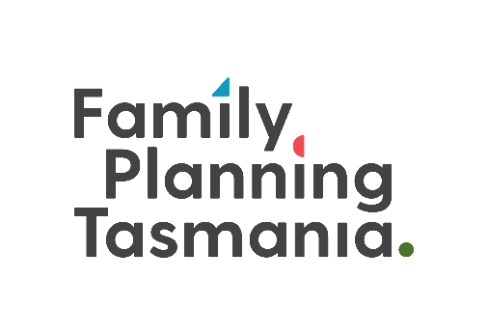
Education Referral Form

NAME
DOB
Gender
Contact details: | Address:  Email:  Telephone:
Aboriginal/Torres Strait Islander? | Yes/No
Is the student/client from a non-English speaking background? | Yes/No  Do you require the assistance of an interpreter? If so please let us know which language.
Are you a new client to Family Planning Tasmania?  Are you a new client to Individual Education services with Family Planning Tasmania?  Tick Location of Individual Education | Yes/No  Yes/No  Glenorchy Launceston  Burnie Online  Other:
Support person and or referring person details  *Please note a support  A person is required at the appointment* | Name:  Organisation:  Is this a Government organisation? Yes / No  Email:  Telephone:
Is your referral related to any current legal proceedings or court orders? | Yes / No  If yes, please specify:
Briefly describe the nature and degree of any additional needs.

Education required:  (Please select all that apply). | Public and private including body, places, talk Types of touch  Puberty and adolescents Healthy/Unhealthy relationships  Online safety/use of technology Sexual health, contraception, STI’s  Protective behaviors The reproductive systems  Consent Sexual Feelings  Self-touch/masturbation Categories of relationships and permissible behaviors with people in each category  Identifying help and support Personal hygiene  Other- please specify:
Any additional information:
PLEASE NOTE:

This form will need to be completed and returned to Family Planning Tasmania prior to your first education session.

All clients must have a support person present during education sessions.

All sessions will be held at a Family Planning Tasmania in Glenorchy, Launceston or Burnie unless by prior arrangement. Sessions run for a maximum of thirty minutes. You may be offered a limited number of follow-up sessions if required.

Online sessions may be offered in some circumstances. If you wish to discuss online education please notify staff at the time of booking.

Some education sessions may incur a professional service charge.

Should you require reports, letters of attendance or additional documentation from your education session please notify staff prior to your appointment.

Please return to:
Family Planning Tasmania
Ph: (03) 6128 3402
Email: an@fpt.asn.au
fpt.org.au

